DAY 14
Wazuh Active Response — Automated Threat Containment
// 01 ACTIVE RESPONSE CONFIGURATION
Active response moves Wazuh from a passive detection role into an automated containment role. Instead of only alerting on a brute-force condition, the manager dispatches a command to the affected agent, which executes a script that takes direct action on the host — in this case, adding a firewall drop rule against the offending source IP. The configuration below was applied on the Wazuh Manager and scoped to the existing SSH brute-force detection rule.
$ Configuration File Location
Path: /var/ossec/etc/ossec.conf (on the Wazuh Manager)
$ Active-Response Block Applied
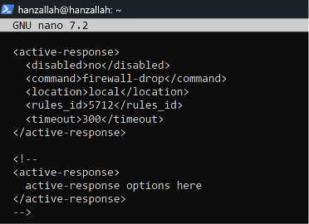
ossec.conf — active-response block configured on the Wazuh Manager

$ Key Settings Explained
- command — firewall-drop: the default Wazuh script that inserts an iptables DROP rule for the offending source IP. No custom script was required.
- location — local: the response executes on the same host where the rule fired. In this lab the Wazuh Manager and the monitored SSH service run on the same Ubuntu Server, so a local response was correct.
- rules_id — 5712: the existing default rule for correlated SSH brute-force attempts against non-existent users, already validated in Week 1 (326 correlated alerts, MITRE T1110).
- timeout — 300: the block is lifted automatically after 5 minutes, which is short enough to observe both the block and its expiry during testing without a long wait.
After saving the file, the Wazuh Manager service was restarted, and the dashboard was checked to confirm all agents still reported an Active status before testing began.

// 02 TEST EXECUTION — SSH BRUTE FORCE TRIGGER
$ Test Condition
From the Kali Linux VM (192.168.56.102), six consecutive SSH attempts were made against the Ubuntu Server (192.168.56.10) using a non-existent account and an incorrect password, exceeding the five-attempt threshold on rule 5712.
for i in {1..6}; do ssh wronguser@192.168.56.10; done
$ Result — iptables Block Confirmed
Immediately after the threshold was crossed, the iptables ruleset on the Ubuntu Server was checked. A DROP rule against the Kali IP appeared on both the INPUT and FORWARD chains, confirming the response executed at the operating-system level.
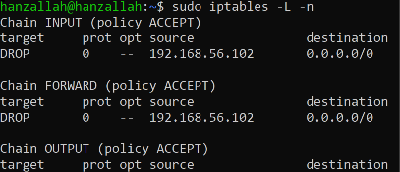
iptables -L -n — DROP rule against 192.168.56.102 on INPUT and FORWARD chains

$ Result — Connection Verified Blocked
A further SSH attempt from Kali was refused first with a password rejection, then timed out entirely once the drop rule took effect — confirming the block was live and not just logged.
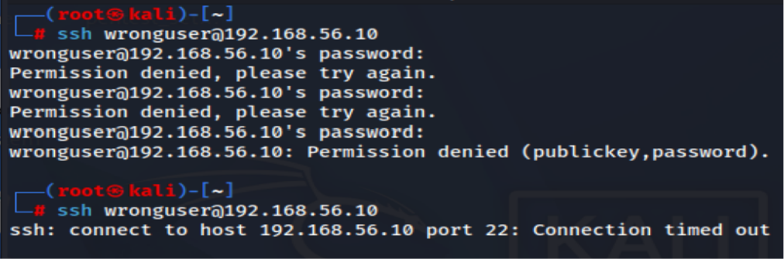
SSH from Kali — permission denied, then connection timed out under the active block

// 03 ACTIVE RESPONSE VERIFICATION — MANAGER LOG
The Wazuh dashboard did not surface a distinct alert for the active-response execution itself under a standard search. To confirm the command actually ran, the manager-side active-responses.log was checked directly, which is the authoritative record of active-response executions independent of dashboard indexing.
Path: /var/ossec/logs/active-responses.log
The log confirms rule 5712 fired twice against repeated failed logins from the Kali IP, and that wazuh-execd issued an add command to firewall-drop at 03:13:00 — directly correlated to the SSH flood run seconds earlier. This is independent, manager-side proof that the response executed as configured.
$ Issues Encountered
- No active-response alert visible in dashboard search: filtering by rule ID or the term "firewall-drop" returned no dashboard alert for the command execution itself, even though the SSH brute-force alerts and the OS-level block were both confirmed. Active-response executions are logged by wazuh-execd to active-responses.log on the manager rather than always being indexed as a standard rule-based alert. Resolution: verified the execution directly from the manager log instead of relying on the dashboard, which gave a clear, timestamped confirmation of the command, the triggering rule, and the source IP.

// 04 RISKS & SAFEGUARDS
$ Risk Note
Active response is powerful precisely because it removes the human from the loop, which is also what makes it dangerous if misconfigured. A legitimate user who mistypes their password five times in a row would be locked out identically to an attacker, with no distinction made between intent and accident — in a production environment this becomes a support burden and, at scale, a usable denial-of-service vector. More seriously, an attacker aware that active response is enabled could spoof the source IP of a critical internal server (a domain controller, a load balancer, a monitoring host) to trigger the same brute-force rule and have the manager block that server automatically, turning a defensive control into a self-inflicted outage.Before enabling this on a production system, the response should be scoped narrowly: an allowlist of critical infrastructure and management IPs that can never be blocked regardless of rule matches, a higher and more deliberately-tuned failure threshold than the default, alerting to a human analyst whenever a block is applied rather than letting it happen silently, and a short, bounded timeout so any false positive self-corrects quickly rather than persisting indefinitely. Active response should be treated as a tool that buys time for a human to react, not as an unsupervised decision-maker.

// 05 WEEK 2 CONCLUSION
Week 2 moved the lab from passive visibility into active detection engineering, and by Day 14, into automated response. Where Week 1 was about proving the SOC lab could see traffic and correlate a basic attack, Week 2 was about proving it could be configured, tuned, and trusted to act — each pair of days added a distinct capability, and each one surfaced a real failure that had to be diagnosed properly rather than worked around.
- Days 8–9 — File Integrity Monitoring: syscheck was configured on the endpoints to establish a baseline for unauthorized file and configuration changes. This gave the manager visibility into tampering the moment it happened, rather than after the fact through log correlation alone, and confirmed that FIM alerts were reaching the dashboard with the correct file paths and change type.
- Days 10–11 — Custom Detection Rules: writing rules from scratch, rather than relying on the default ruleset, surfaced problems that only show up when you build something yourself: a rule ID collision with an existing rule, a rule that referenced the wrong base rule ID and never fired, and a USB-detection rule that silently failed until traced through wazuh-logtest. Each of these forced a proper diagnostic workflow — test the rule in isolation, read the exact match output, and confirm the fix against a real event — instead of guessing at a fix and re-testing blindly.
- Days 12–13 — Log Analysis: correlating Windows Event ID 4625 (failed logon) through smbclient tied a raw log line to a concrete, named technique — MITRE T1531 — and confirmed the manager could pull meaningful signal from a Windows source, not only Linux syslog. This is also where the reporting format matured: real troubleshooting sessions were documented as their own subsections rather than folded into the narrative, which made the report easier to audit and matches how an actual incident writeup should read.
- Day 14 — Active Response: the SSH brute-force detection built in Week 1 was turned into an automated containment control. A rule firing now results in a real iptables block, independently verified at the OS level and through the manager's own active-response log, with the dashboard-visibility gap called out explicitly as a genuine operational finding rather than smoothed over in the writeup.
The recurring pattern across all four pairs of days was the same regardless of the specific feature being configured: set something up, watch it fail or behave unexpectedly, diagnose the failure using the manager's own tools and logs rather than assumption, and then verify the fix at more than one layer — the rule engine, the OS, and where possible an independent log source. That habit is worth more than any individual rule, command, or configuration block covered this week, because it is the same habit a working SOC analyst relies on when the documentation doesn't match reality and the dashboard doesn't show everything.
Practically, Week 2 also raised the bar on what "done" means for a lab exercise. It is no longer enough for a detection to exist — it has to be tested against a real triggering condition, its failure modes have to be understood, and its output has to be confirmed independently rather than trusted on faith. Carrying that standard into Week 3 — wherever the focus shifts next, whether that is alerting pipelines, threat hunting, or deeper correlation rules — is the most direct continuation of what these six days were building toward.

